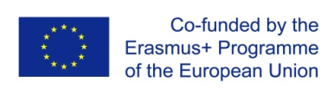 | Development of master curricula for natural disasters risk management in Western Balkan countries | 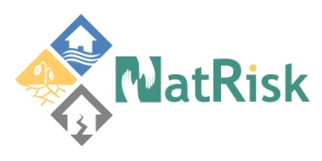

Agenda – Event

Project title: Development of master curricula for natural disasters risk management in Western Balkan countries
Acronym: NatRisk
Project number:
573806-EPP-1-2016-1-RS-EPPKA2-CBHE-JP

Work package | Title
xxx | xxx
Activity | Title
xxx | xxx

Dates |  |  | xxx to xxx  (Arrival date: xxx, Departure date: xxx)
City
Meeting venue
Address
 |  |  |  | Development of master curricula for natural disasters risk management in Western Balkan countries
Day, Date
Address
10:00-10:30 | NatRisk participants registration
1st Session -
10:30-11:00 | Welcome speeches
11:00-11:30
11:30-12:00
12:00-12:45 | Buffet lunch
2nd Session –
12:45-13:30
13:30-14:30
14:30-14:45 | Coffee break
3rd Session –
14:45-15:45

Day, Date
Address
4th Session –
09:15-09:30
09:30-10:45
10:45-11:15 | Coffee break
16:15-16:30 | General discussion and closing the meeting

